STUDY OF pp COLLISIONS AT LHC – THE CMS EXPERIMENT

(V. Adler, O. Bouhali, E. Chabert, O. Charaf, B. Clerbaux, G. De Lentdecker, V. Dero, O. Devroede, S. De Weirdt, J.P. Dewulf, J. D'Hondt, Sh. Elgammal, R. Goorens, G. Hammad, J. Heyninck, J. Maes, M. Mozer, P. Marage, S. Tavernier, C. Vander Velde, W. Van Doninck, P. Vanlaer, L. Van Lancker, P. Van Mulders, I. Villela, J. Wickens).

During the year 2008, the Large Hadron Collider (LHC) has completed its construction phase. This machine, which will allow to study proton-proton interactions at a centre-of-mass energy of 14 TeV with luminosities around 10³⁴c⁻² s⁻¹, is expected to start during the summer 2008. Two multipurpose detectors, ATLAS and CMS, are installed at the LHC.

A vast research program will be performed at this collider. The machine and detectors have been optimized for the search for new physics at high energy, with particular focus on the discovery of the Higgs boson(s) over a very large mass range. It will discriminate between different theories to extend the Standard Model, with, for example, the observation of supersymmetric particles or with manifestation of extra spatial dimensions. Studies of the top quark properties will become possible due to the large top pair production rate.

The Compact Muon Solenoid (CMS) collaboration consists of more than 2500 physicists and engineers from 176 institutes all over the world among which six Belgian research groups from the IIHE (ULB- VUB), UA, UCL UG and UMH. Gent joined the collaboration only recently and is participating to the construction of still missing RPC muon chambers. The five other Belgian teams have chosen already in 2000, to participate to the design and construction of the Silicon tracker detector of CMS.

The CMS experiment has been taking several runs to collect cosmic particles flying through the detector. This helps significantly in the commissioning and the alignments of the individual detectors. The data accumulated with these cosmic runs also gave the possibility to test the computing infrastructure and the offline workflows. In the first part of 2008 these cosmic runs were taken when the magnetic field was off, the so-called CRUZET runs. Later in the year global runs with the full magnetic field of 3.8 Tesla were recorded, the so-called CRAFT runs.

In 2008, physicists from the IIHE participated to shifts during data taking with cosmic rays, at CERN. For these tests, 20% of the full tracker was used, allowing testing the full data taking and online monitoring chain. The tracker data obtained were of very high quality, demonstrating that it fully satisfies the specifications. In December, the full tracker was lowered to the experimental area, 100 m underground and inserted successfully into CMS.

Members of the IIHE have contributed to specific Data Quality Monitoring developments concerning the Silicon Strip Tracker. These offline tools were deployed for the first time during global runs collecting cosmic particles.

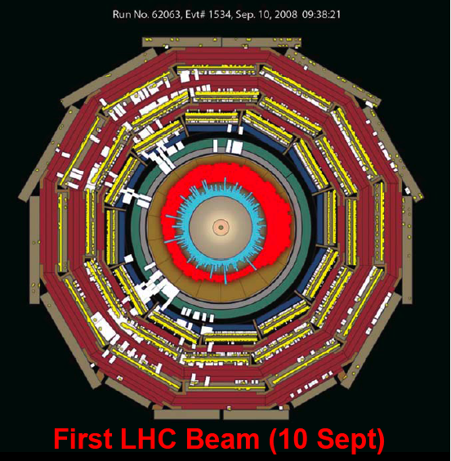
Splash of particles within the CMS detector coming from the first proton beams in the LHC machine.

On the 10th of September all journals and television news was focused towards the start-up of the LHC machine. On that they we succeeded in circulating protons in both directions in the collider. This is a milestone for the machine and opens the door to the exploration of Nature at the highest energy frontier. Also the Belgian press was omnipresent during these days. The Belgian labs have organized a successful press conference on this topic, of which the document can be found in appendix. The first proton beams gave also a splash of particles in the CMS detector.

During the 19th of September a sever accident happened however at the LHC. The electric connection between a dipole and a quadrupole experienced a short when increasing the current to about 9300 Amperes. Although safety systems are installed for these quenches, the an electrical arc developed and punctured the helium enclosure, leading to release of helium into the insulation vacuum of the cryostat. The large pressure forces acting on the vacuum barriers caused displaced dipoles, in some cases even breaking the anchors in the concrete floor of the tunnel. This incident forces CERN to design a new schedule for the machine start-up and to invest more into a dedicated safety system. The new start-up of the machine is foreseen for September 2009.

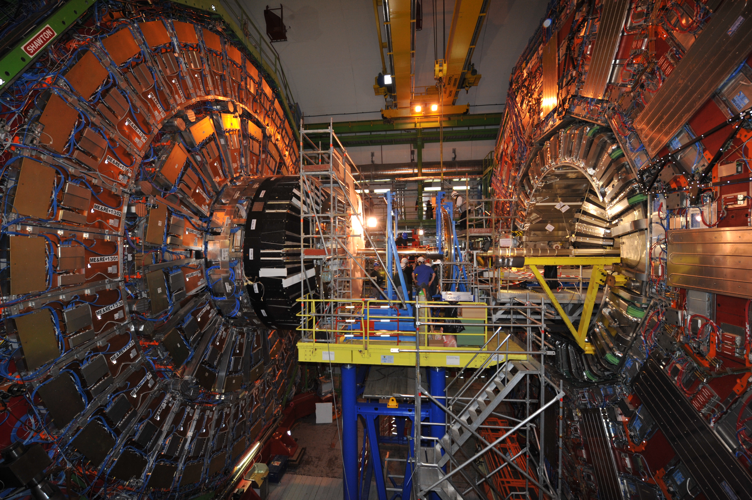
Installation of one of the last elements in the CMS detector, namely the pre-shower (March 09).

In parallel, the CMS physicists of the IIHE continue to prepare the physics analyses. They contribute to the simulation studies of several physics channels of high relevance at the LHC. They participate to the development of the simulation and reconstruction programs which are required in order to perform the analyses. The two main physics topics are the search for high mass resonances decaying into electron or photon pairs and the study of the semi-leptonic decay of top-antitop quark pairs.

Search for high mass resonances:

Barbara ??

Study of top quark pairs:

The top quark is the heaviest particle within the Standard Model of particle physics. Due to its high mass it was only discovered in 1995 at the proton/anti-proton Tevatron collider (Chicago, U.S.). In the exploitation phase of the Large Hadron Collider millions of top quarks will be produced each year. These data will open a new window to precision measurements of the properties of the top quark and their production mechanisms. With these measurements, the Standard Model will be tested at its frontier. Moreover, any deviation from the Standard Model predictions might reveal new physics, beyond the Standard Model.

The physicists from the IIHE aim to contribute to a precise determination of the top quark mass from semi-leptonic decaying top quark pair events, with a total uncertainty of ~1 GeV/c² or better. This potential measurement would be the most precise measurement of this Standard Model parameter. They also plan to measure the top quark pair production cross-section and to study spin correlations through the study of angular distributions. New physics will be searched for by studying some topological and kinematical characteristics of the events. The first variable to be investigated will be the top-antitop invariant mass as the shape of its distribution is expected to be very little affected by the presence of remaining QCD background. The existence of a new massive particle like an additional gauge boson Z' would show up as a peak in such distribution. In the case of the two doublets Higgs model, the existence of a scalar Higgs boson might be revealed by a more general distortion of the invariant mass distribution.

But before tackling these exciting physics issues with the first data expected late in 2009, the reconstruction procedures, the event selection and the statistics analysis tools need to be built and tested. The IIHE physicists worked on the implementation and testing of analyses which use few data, namely of about 10 to 100/pb of intergrated luminosity. An simplified event selection was designed for this early physics and a method was developed to estimate the background directly from the data. New ideas were developed to have all our analyses in a data driven format, which means that we redesign the analysis to have as little as possible dependence on Monte-Carlo simulations. This gives rise to new measurement methods to observe spin correlations between the top and anti-top quark and to new techniques to estimate the b-tagging efficiency. Currently we are testing the performance of these novel methods with Monte-Carlo simulation.

The year 2008 was also used to further investigate some crucial steps of future analyses. The strategy for the estimation of the jet energy scale corrections was refined. These corrections are based on Monte Carlo simulations tuned first on beam test data and later, when available, on collider data. They take into account offset corrections for pile-up, noise, and effects of thresholds, dependence of the calorimeter response to the jet pseudorapidity and transverse momentum, jet flavor and contribution of the underlying events. The method to estimate the efficiencies for tagging the b-quark, and c-quark jets from data has been further worked out. Event samples identified as semi-leptonic and fully-leptonic decays of the top-antitop pairs are used. Different techniques based on extraction of high purity b-flavored jets, or on requiring the consistency between the observed and expected numbers of tags in the events will be used to study the heavy flavor algorithms. These techniques can also be extended to measure the mis-tag rates for light quark jets in the future. The simulation of more QCD events showed that the foreseen cuts are not sufficient to reject this background; better cuts are being designed. A precise estimation of the QCD contribution is needed as the cross-section of this channel is huge compared to this of the top signal. As the QCD cross-section normalization is poorly predicted, a method to normalize it with data is being studied.

Finally, since December 2006 and for two years, Jorgen D'Hondt, is convenor of the group in charge of the physics analyses on the top quarks for the whole CMS collaboration.

Grid developments:

In 2008 the IIHE further deployed the Belgian “Tier-2” cluster integrated in the hierarchy of computing centers that will process the data of the CMS experiment. The Belgian “Tier-2” is a federation of 2 sites, one in Brussels and one in Louvain-la-Neuve. The Brussels site hosts the contributions of the UA, UGent, UMH, ULB and VUB in computing power and disks. Those are funded by the F.R.S.-FNRS and by the FWO-Flemish Community. It is meant to support the analyses of the Belgian CMS physicists, ~50 people from both French-speaking and Flemish universities, in collaboration with the UCL site.

A very important step of this deployment materialized in 2008. The cluster migrated from its location at IIHE to the infrastructures of the ULB-VUB computing center, according to an agreement that was negotiated in 2007. The cluster now benefits from:
- a reliable, large-bandwidth connection (1 Gb/s) to the GEANT research network;
- common air conditioning and electric power network allowing to save costs.
Three full-time IT scientists (S.Rugovac - F.R.S.-FNRS, O.Devroede – FWO, S.Gérard - ULB) are currently in charge of the Tier-2 deployment and user support. The physicist in charge and representative to the W-LCG and CMS computing boards is P.Vanlaer. S.Gérard could be hired on a temporary position in replacement for O.Bouhali, on leave of absence from ULB for an executive position to deploy a cluster in the Doha Education City (Qatar). O. Devroede is now the technical coordinator of the Belgian Tier-2, and has replaced S.De Weirdt, who left us for an executive position at the Vlaams Supercomputing Center.

The disk storage of the IIHE Tier-2 was extended by 170 TB, reaching 260 TB of storage. This disk space is meant to host data samples of three kinds: 1) general interest to the CMS collaboration, 2) samples for CMS physics analysis groups and 3) samples for the analyses performed in Belgium, each for about one third of the disk space.

The computing power was not extended on CMS budget in 2008. The delays due to the LHC incident allowed the spendings in computing power to be postponed for a better performance-to-cost ratio. The IIHE Tier-2, however, benefits from general-purpose computing power installed in the framework of the BELNET grid project, Begrid. The total number of processing power available at the IIHE Tier-2 is currently 500 kSi2K, 300 of which being funded on CMS budget. The IIHE site offers 340 batch slots for CMS simulation and analysis jobs.

As all CMS Tier-2 sites the IIHE site is tested daily by CMS for its availability, its reliability and the number of links to other sites that are operational. The results of these tests are combined into a readiness metric. According to this metric, the IIHE site is among the top 10 most ready sites in the Collaboration in March 2009 (See figure). The reproducibility of this good performance has still to be consolidated in view of the LHC data taking period.

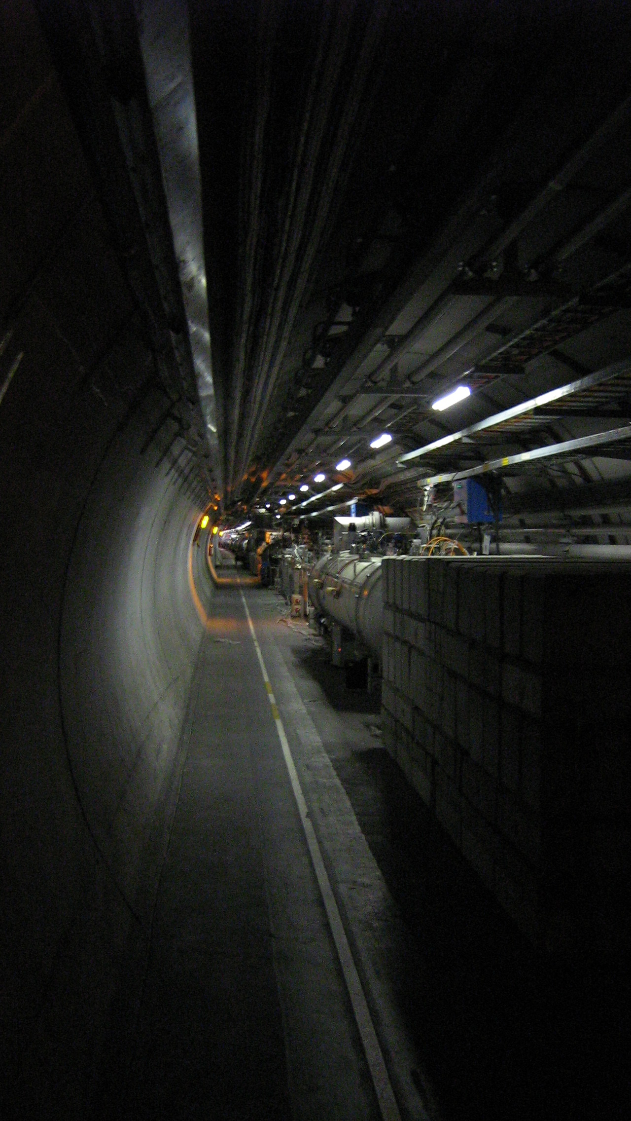

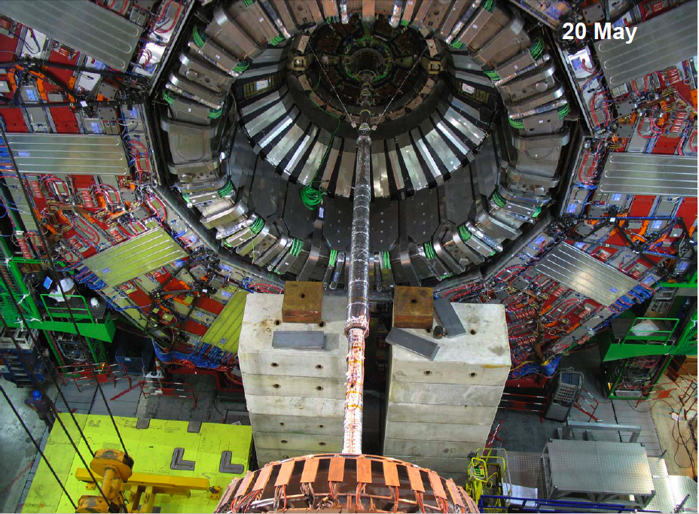
Installation of the beam pipe in CMS (minus-side).
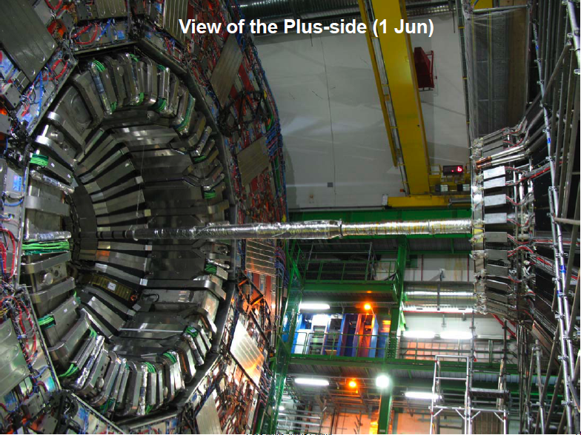
Installation of the beam pipe in CMS (plus-side)

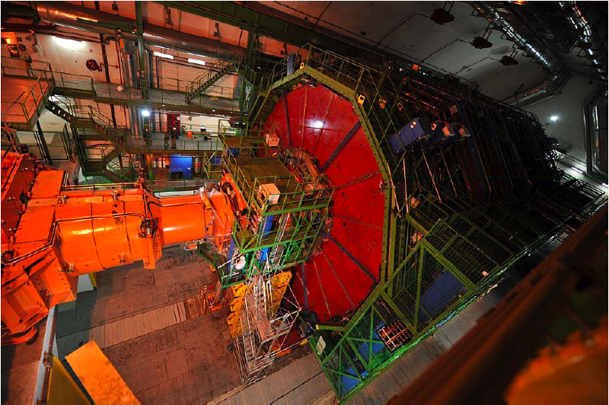
Final closure of the CMS detector, ready for collisions before the 10th of September 2008 (picture taken on September 3rd).

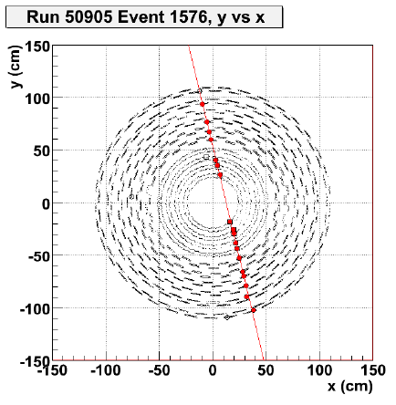
Cosmic rays in the Silicon Strip Tracker of CMS taken during CRUZET runs (zero magnetic field) help in the commissioning phase of the experiment.

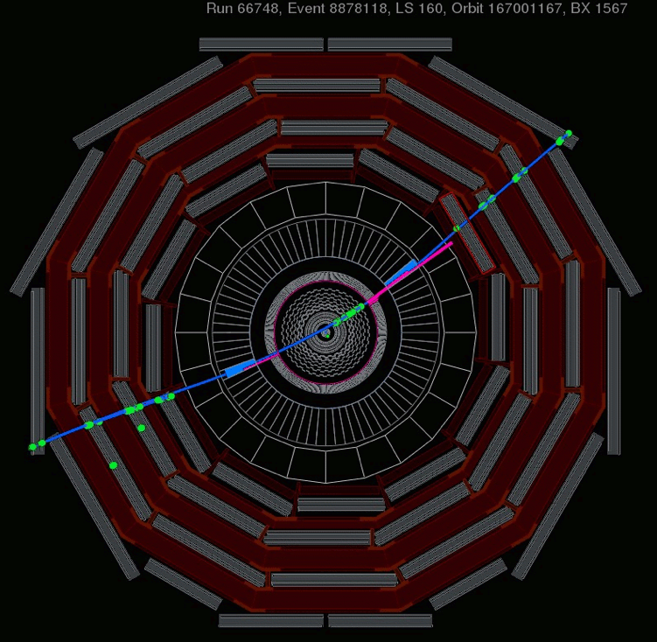
Reconstruction of cosmic rays in the CMS detector taken during the so-called CRAFT runs (with magnetic field at 3.8 Tesla).

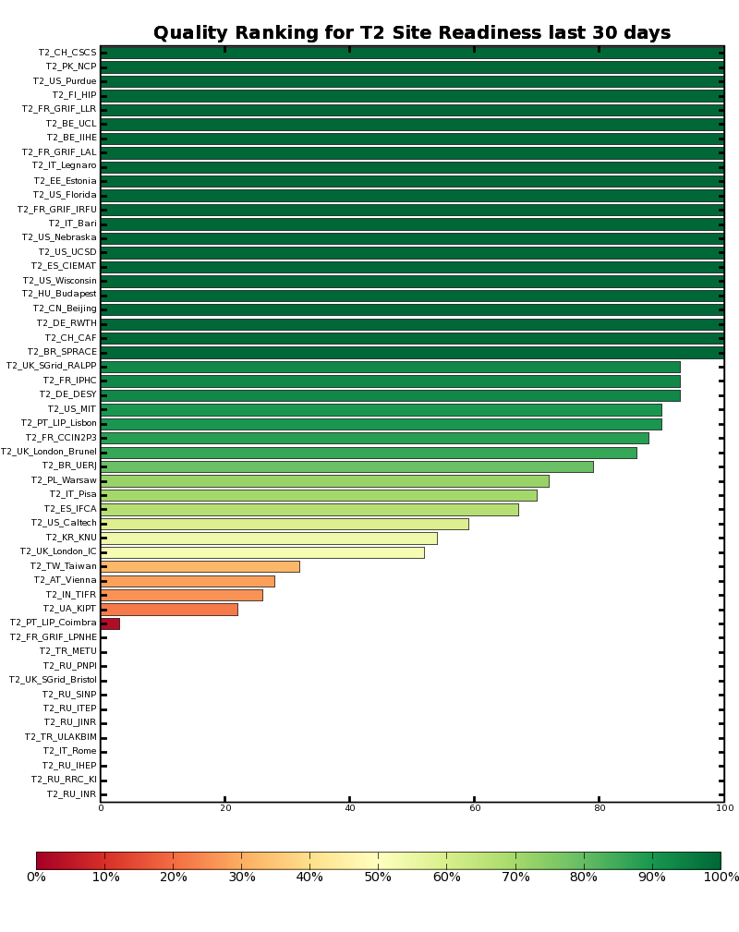
Illustration 1: Readiness metric of CMS Tier-2 sites for a 30 day period until March 23, 2009

